**SPH3U: 4.1 Gravitational Force near Earth**

1. **Air resistance and free fall**

Which piece of paper will reach the ground first? Flat paper Crumpled paper

|  |  |
| --- | --- |
| Free fall: |  |
| air resistance |  |
| terminal speed |  |

**Skydiver:**

|  |  |  |
| --- | --- | --- |
| **First leaving the plane** | **Falling for a while** | **No longer accelerating** |
|  |  |  |
| **Open parachute** | **Slowed down a bit** | **Falling constant speed** |
|  |  |  |

|  |  |
| --- | --- |
| **Drag force:**  F_D\, =\, \tfrac12\, \rho\, v^2\, C_D\, A | *FD* is the drag force,  *ρ* is the density of the fluid,  *v* is the speed of the object relative to the fluid,  *A* is the cross sectional area, and  *CD* is the drag coefficient – a dimensionless number. |

1. **Gravitational field strength**

|  |  |
| --- | --- |
| Force field: |  |
| gravitational field strength |  |
| *g* in Toronto |  |
| *g* 6,371 km above Earth’s surface |  |

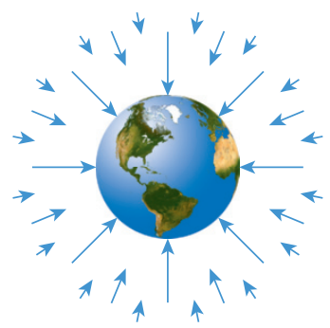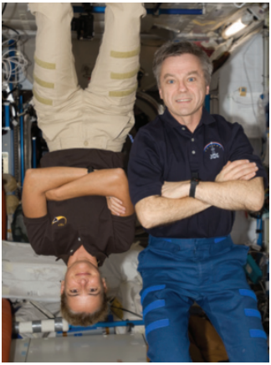

1. **The difference between mass and weight**

|  |  |
| --- | --- |
| Mass: |  |
| Weight: |  |
| “weightlessness” or “microgravity” |  |
| International Space Station (ISS) |  |

1. **Normal force: not always equal to gravity**

A cart rolls down an incline. Assume that friction is negligible. Draw an FBD for the cart. In which directions do the normal force and the force of gravity act on the cart?

A 50 kg person is standing on a bathroom scale inside an elevator. The scale is calibrated in newtons. What is the reading on the scale when the elevator is accelerating up at 2.2 m/s2?

A 60.0 kg person is standing on a bathroom scale calibrated in newtons. A friend pushes down on the person with a force of 72.0 N. What is the reading on the scale?

**Homework:** page 167: #1-3, 5-7